Inception module V4

0. Environment

|  |  |
| --- | --- |
| DataSet | CIFAR-10 |
| Language | Python3.5 & Tensorflow 1.0 |
| optimizer | Adam |
| Loss function | Cross entropy Loss |

Input : 32x32x3 size image

1. initialize

|  |  |
| --- | --- |
| layer | max_pool(stride = 2, pool_size = 2, pad) |
| output | 16x16x3 |
| layer | 1x1 conv (filter = 64) |
| output | 16x16x64 |

2. module (10 times)

|  |  |  |  |  |
| --- | --- | --- | --- | --- |
| layer | 1x1 conv  (fileter = 16) | 1x1 conv  (fileter = 16) | 1x1 conv  (fileter = 16) | max_pool  (size = 3x3, pad) |
| 3x3 conv  (filter = 16, pad) | 3x3 conv  (filter = 16, pad) | 1x1 conv  (filter = 16, pad) |
| 3x3 conv  (filter = 16, pad) |
| output | 16x16x16 | 16x16x16 | 16x16x16 | 16x16x16 |
| concatenate | 16x16x64 | | | |
| Layer | relu | | | |
| output | 16x16x64 | | | |

3. 1x1 conv & avg_pool(Using NIN) # *instead of Fully connected layer*

|  |  |
| --- | --- |
| layer | 1x1 conv (filter = 16) |
| output | 16x16x16 |
| layer | 1x1 conv (filter = 10) |
| output | 16x16x10 |
| layer | 16x16 avg_pool |
| output | 10 |

4. Overall

|  |  |
| --- | --- |
| Training(7600 iteration) | Time : 4071.6925914287567 seconds |
| Accuracy : 0.68 |
| Validation | Accuracy : 0.643 |
| Re-training(64 iteration) | Accuracy : 0.684 |
| Re-Validation | Accuracy : 0.643 |
| Test | Acurracy : 0.641 |

Training

Iteration 0: with minibatch training loss = 26.8 and accuracy of 0.047

Iteration 100: with minibatch training loss = 2.02 and accuracy of 0.27

Iteration 200: with minibatch training loss = 1.82 and accuracy of 0.27

Iteration 300: with minibatch training loss = 1.65 and accuracy of 0.44

Iteration 400: with minibatch training loss = 1.7 and accuracy of 0.33

Iteration 500: with minibatch training loss = 1.52 and accuracy of 0.41

Iteration 600: with minibatch training loss = 1.54 and accuracy of 0.5

Iteration 700: with minibatch training loss = 1.6 and accuracy of 0.41

Epoch 1, Overall loss = 1.82 and accuracy of 0.337

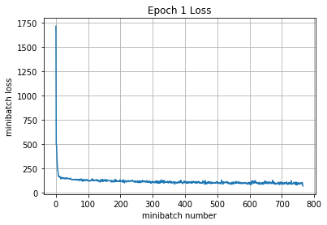

Iteration 800: with minibatch training loss = 1.49 and accuracy of 0.5

Iteration 900: with minibatch training loss = 1.74 and accuracy of 0.34

Iteration 1000: with minibatch training loss = 1.29 and accuracy of 0.58

Iteration 1100: with minibatch training loss = 1.34 and accuracy of 0.52

Iteration 1200: with minibatch training loss = 1.33 and accuracy of 0.47

Iteration 1300: with minibatch training loss = 1.06 and accuracy of 0.56

Iteration 1400: with minibatch training loss = 1.23 and accuracy of 0.52

Iteration 1500: with minibatch training loss = 1.19 and accuracy of 0.64

Epoch 2, Overall loss = 1.41 and accuracy of 0.484

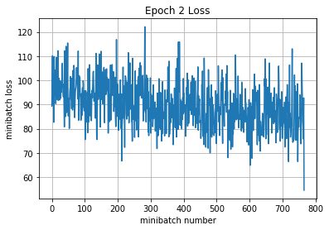

Iteration 1600: with minibatch training loss = 1.41 and accuracy of 0.53

Iteration 1700: with minibatch training loss = 1.35 and accuracy of 0.52

Iteration 1800: with minibatch training loss = 1.47 and accuracy of 0.53

Iteration 1900: with minibatch training loss = 1.04 and accuracy of 0.7

Iteration 2000: with minibatch training loss = 1.11 and accuracy of 0.59

Iteration 2100: with minibatch training loss = 1.15 and accuracy of 0.59

Iteration 2200: with minibatch training loss = 1.39 and accuracy of 0.48

Epoch 3, Overall loss = 1.25 and accuracy of 0.549

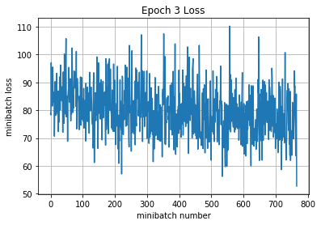

Iteration 2300: with minibatch training loss = 1.43 and accuracy of 0.44

Iteration 2400: with minibatch training loss = 1.02 and accuracy of 0.61

Iteration 2500: with minibatch training loss = 1.08 and accuracy of 0.56

Iteration 2600: with minibatch training loss = 1.02 and accuracy of 0.66

Iteration 2700: with minibatch training loss = 1.04 and accuracy of 0.58

Iteration 2800: with minibatch training loss = 0.977 and accuracy of 0.62

Iteration 2900: with minibatch training loss = 0.965 and accuracy of 0.64

Iteration 3000: with minibatch training loss = 0.979 and accuracy of 0.64

Epoch 4, Overall loss = 1.16 and accuracy of 0.583

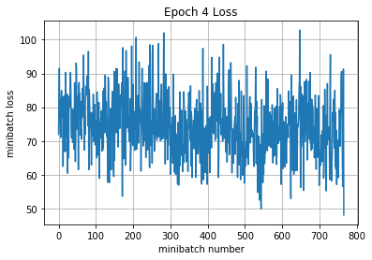

Iteration 3100: with minibatch training loss = 1.07 and accuracy of 0.61

Iteration 3200: with minibatch training loss = 0.792 and accuracy of 0.7

Iteration 3300: with minibatch training loss = 1.18 and accuracy of 0.52

Iteration 3400: with minibatch training loss = 1.15 and accuracy of 0.59

Iteration 3500: with minibatch training loss = 1.14 and accuracy of 0.59

Iteration 3600: with minibatch training loss = 1.03 and accuracy of 0.56

Iteration 3700: with minibatch training loss = 0.9 and accuracy of 0.66

Iteration 3800: with minibatch training loss = 1.15 and accuracy of 0.64

Epoch 5, Overall loss = 1.09 and accuracy of 0.607

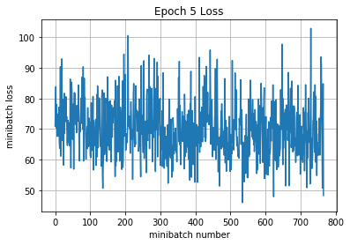

Iteration 3900: with minibatch training loss = 1.05 and accuracy of 0.64

Iteration 4000: with minibatch training loss = 1.01 and accuracy of 0.62

Iteration 4100: with minibatch training loss = 1.32 and accuracy of 0.48

Iteration 4200: with minibatch training loss = 1.27 and accuracy of 0.56

Iteration 4300: with minibatch training loss = 1.02 and accuracy of 0.59

Iteration 4400: with minibatch training loss = 1.23 and accuracy of 0.53

Iteration 4500: with minibatch training loss = 1.1 and accuracy of 0.67

Epoch 6, Overall loss = 1.04 and accuracy of 0.632

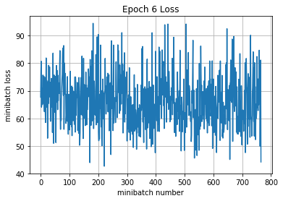

Iteration 4600: with minibatch training loss = 1.01 and accuracy of 0.66

Iteration 4700: with minibatch training loss = 0.837 and accuracy of 0.72

Iteration 4800: with minibatch training loss = 0.803 and accuracy of 0.75

Iteration 4900: with minibatch training loss = 0.923 and accuracy of 0.64

Iteration 5000: with minibatch training loss = 1.02 and accuracy of 0.62

Iteration 5100: with minibatch training loss = 0.836 and accuracy of 0.69

Iteration 5200: with minibatch training loss = 1.02 and accuracy of 0.64

Iteration 5300: with minibatch training loss = 0.982 and accuracy of 0.64

Epoch 7, Overall loss = 0.989 and accuracy of 0.649

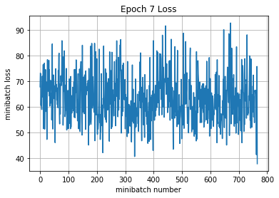

Iteration 5400: with minibatch training loss = 1.01 and accuracy of 0.67

Iteration 5500: with minibatch training loss = 0.858 and accuracy of 0.66

Iteration 5600: with minibatch training loss = 0.847 and accuracy of 0.67

Iteration 5700: with minibatch training loss = 0.903 and accuracy of 0.7

Iteration 5800: with minibatch training loss = 1.1 and accuracy of 0.56

Iteration 5900: with minibatch training loss = 0.814 and accuracy of 0.7

Iteration 6000: with minibatch training loss = 0.886 and accuracy of 0.67

Iteration 6100: with minibatch training loss = 1.22 and accuracy of 0.56

Epoch 8, Overall loss = 0.954 and accuracy of 0.66

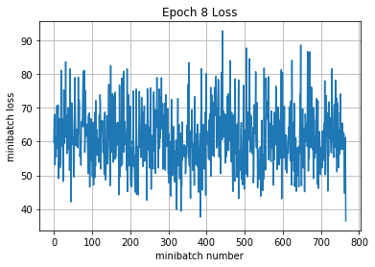

Iteration 6200: with minibatch training loss = 0.996 and accuracy of 0.61

Iteration 6300: with minibatch training loss = 1.09 and accuracy of 0.66

Iteration 6400: with minibatch training loss = 1.09 and accuracy of 0.61

Iteration 6500: with minibatch training loss = 0.885 and accuracy of 0.59

Iteration 6600: with minibatch training loss = 0.983 and accuracy of 0.64

Iteration 6700: with minibatch training loss = 0.82 and accuracy of 0.69

Iteration 6800: with minibatch training loss = 1.06 and accuracy of 0.66

Epoch 9, Overall loss = 0.922 and accuracy of 0.672

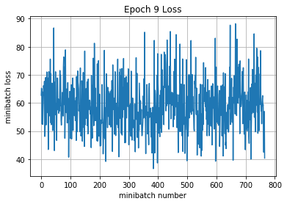

Iteration 6900: with minibatch training loss = 0.88 and accuracy of 0.72

Iteration 7000: with minibatch training loss = 0.823 and accuracy of 0.67

Iteration 7100: with minibatch training loss = 0.861 and accuracy of 0.67

Iteration 7200: with minibatch training loss = 0.867 and accuracy of 0.67

Iteration 7300: with minibatch training loss = 0.721 and accuracy of 0.69

Iteration 7400: with minibatch training loss = 0.872 and accuracy of 0.64

Iteration 7500: with minibatch training loss = 0.909 and accuracy of 0.72

Iteration 7600: with minibatch training loss = 0.885 and accuracy of 0.66

Epoch 10, Overall loss = 0.897 and accuracy of 0.68

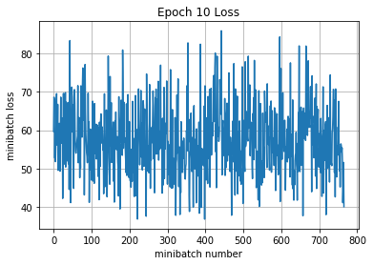

4071.6925914287567

Validation

Epoch 1, Overall loss = 1.03 and accuracy of 0.643

Training

Epoch 1, Overall loss = 0.899 and accuracy of 0.684

Validation

Epoch 1, Overall loss = 1.03 and accuracy of 0.643

Test

Epoch 1, Overall loss = 1.05 and accuracy of 0.641